Name : Shan
Sap : 72387
BSAI
PF LAB
LAB TASK 6
Assignment

Q: Write a program to store integer salaries of 6 employees in the form of array. Get input from user and display on the screen with / without loop/

#include <iostream>
using namespace std;

int main() {
int salary[6];
cout << "72387_Shan..._Task_6\n";
cout << "Enter salaries of 6 employees:\n";
for(int i = 0; i < 6; i++) {
cout << "Salary " << i + 1 << ": ";
cin >> salary[i];
}
cout << "\nSalaries you entered:\n";
for(int i = 0; i < 6; i++) {
cout << salary[i] << endl; } return 0; }
/* #include <iostream>
using namespace std;
int main() {
int salary[6];
cout << "72387_Shan..._Task_6\n";
cout << "Enter salaries of 6 employees:\n";
cin >> salary[0];
cin >> salary[1];
cin >> salary[2];
cin >> salary[3];
cin >> salary[4];
cin >> salary[5];
cout << "\nSalaries you entered:\n";
cout << salary[0] << endl;
cout << salary[1] << endl;
cout << salary[2] << endl;
cout << salary[3] << endl;
cout << salary[4] << endl;
cout << salary[5] << endl;
return 0;
} */

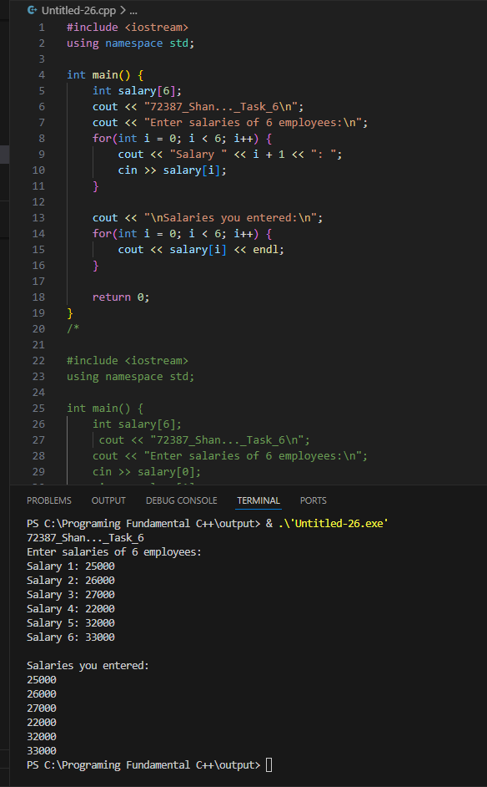

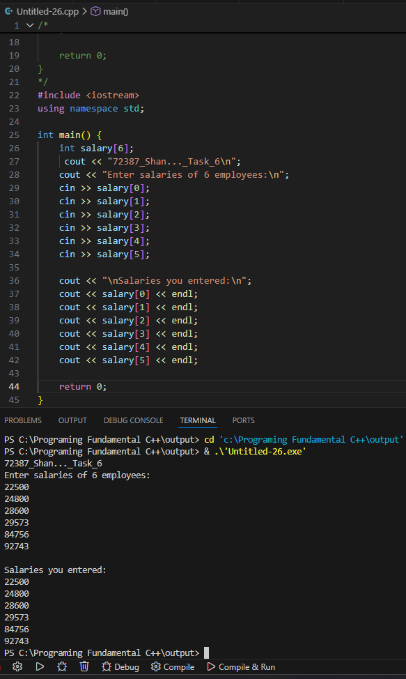

Q: Write a C++ program that takes quiz marks of ten students into an array, calculates their total using a loop, finds the average, and displays the result.

#include <iostream>
using namespace std;

int main() {
int marks[10];
int total = 0;
float average;
cout << "72387_Shan..._Task_6\n";
cout << "Enter quiz marks of 10 students:\n";
for (int i = 0; i < 10; i++) {
cout << "Student " << i + 1 << ": ";
cin >> marks[i];
total += marks[i];
} average = total / 10.0;
cout << "\nTotal Marks = " << total << endl;
cout << "Average Marks = " << average << endl;
return 0; }

